Governance & Proposal
Overview of Governance
Organisational structure of the company
An organisational structure defines how tasks, authority and reporting lines are distributed across an organisation (The University of Sydney, 2026). Four common types exist (Mintzberg, 1979):
- Functional – staff are grouped by specialism (e.g., Engineering, Sales). Roles are clear, but silos can form.
- Hierarchical – many layers and a clear chain of command. Stable and accountable, but slow to decide.
- Flat – few or no middle managers. Fast and innovative, but roles blur as headcount grows.
- Matrix – staff report to a functional manager and a project manager. Strong collaboration, but dual authority can confuse priorities.
Lyra uses a flat, functional–matrix hybrid. With 34 staff, no employee is more than two steps from the CEO (Figure 1). Every employee belongs to one of five functions, which own hiring, standards and professional development. Day-to-day work, however, happens in cross-functional product squads; for example, the Retrieval Quality squad combines machine learning engineers, a learning designer and a customer success contact. This matches the culture described in About the Organisation, where engineers, learning designers and former academics sit in the same squads.
The flat layer keeps decisions fast, which a one-year-old company needs, while the matrix element prevents a silo between engineering and pedagogy that would weaken a curriculum-grounded product. The known weakness of a matrix, competing priorities, is managed by the executive team setting one ranked list of squad priorities each quarter.
Strategic decision making
Lyra allocates decision rights across three tiers (Weill & Ross, 2004). The Board approves decisions that change the company's capital or risk position, such as the annual budget, fundraising and risk appetite for student data and AI. The executive team turns strategy into quarterly objectives linked to the FY2027 targets of eight university-wide licences, 90% renewal and gross margin above 70%. Squads make delivery decisions within that plan, and product claims are settled by evaluation data rather than opinion. Table 1 lists the strategic decisions raised by Lyra's Business Model Canvas (BMC).
Table 1. Strategic decisions drawn from the Business Model Canvas
BMC block | Strategic decision | Decided by
Customer Segments | When to expand beyond NSW pilots to Victoria, Queensland and TAFE | Board
Revenue Streams | EFTSL price bands and which premium modules to charge for | Executive; Board approves
Key Partnerships | How many model providers to use, and on what terms | Executive (CTO)
Cost Structure | Maximum inference cost per EFTSL that still protects a 70% margin | Board sets target; Executive manages
Customer Relationships | How to prove learning impact so that pilots convert and licences renew | Executive (Head of Growth)

The last decision is currently the most urgent and is the focus of this proposal.
Organisation chart
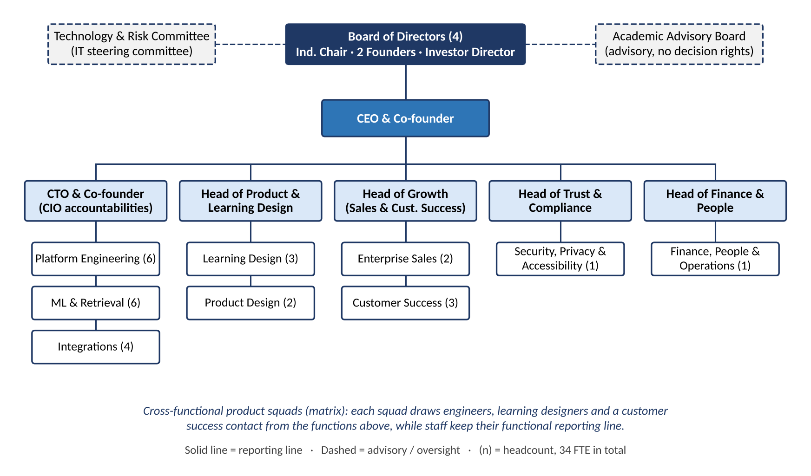
Figure 1. Organisation chart – Lyra Learning Pty Ltd
As a seed-funded proprietary company, Lyra is governed by a four-person Board of Directors: an independent chair with higher-education experience, the two founders (CEO and CTO) and a director nominated by the seed investor. The Corporations Act 2001 (Cth) requires a proprietary company to have only one director; Lyra goes further so that an independent voice and investor oversight balance the founders.
The CEO reports to the Board and leads five heads, who each report directly to the CEO:
- CTO – platform, machine learning and integration engineering (16 staff) and the company's CIO duties.
- Head of Product & Learning Design – roadmap, user experience and pedagogy (5 staff).
- Head of Growth – enterprise sales and customer success (5 staff).
- Head of Trust & Compliance – security, privacy, accessibility and ISO 27001 (1 staff).
- Head of Finance & People – finance, HR, legal and operations (1 staff).
Two bodies sit outside the reporting lines (dashed in Figure 1). The Academic Advisory Board advises on pedagogy and the roadmap but has no decision rights. The Technology & Risk Committee oversees IT and data risk on behalf of the Board, as explained below.
IT in the Governance structure
Because Lyra's product is software, IT is not a support function but a strategic enabler at the centre of the business model (The University of Sydney, 2026). Lyra has no separate CIO; instead, the CTO holds CIO accountabilities for both the product platform and internal IT such as identity, devices and SaaS tools.
To stop the CTO from approving their own work, IT decisions are overseen by a Technology & Risk Committee, which acts as Lyra's IT steering committee. It is chaired by the CEO, meets monthly and includes the CTO, Head of Product & Learning Design, Head of Growth and Head of Trust & Compliance. It ranks IT investments against business objectives, approves major architecture and model-provider changes, and reviews security, privacy and AI-quality risks. It reports quarterly to the Board, which keeps final accountability for IT through the evaluate–direct–monitor model of ISO/IEC 38500 (International Organization for Standardization [ISO], 2024). The Head of Trust & Compliance, as Privacy Officer, gives an independent check on engineering. AW7 develops this structure in detail.
Roles and Responsibilities
Table 2. Business and IT governance roles
Role | Name (Fictional) | Responsibilities
Board Chair (Independent Director) | Dr Margaret Ellison | - Leads the Board, sets its agenda and evaluates the CEO  - Provides independent higher-education expertise  - Ensures directors meet their duties under the Corporations Act
Investor Director | James Whitford | - Represents seed investors on the Board  - Oversees budget, cash runway and fundraising  - Co-approves major capital and risk decisions
Chief Executive Officer (CEO) & Co-founder | Priya Raman | - Sets company strategy and FY2027 objectives  - Leads the executive team and chairs the Technology & Risk Committee  - Owns relationships with university executives (DVC level)  - Accountable to the Board for company performance
Chief Technology Officer (CTO) & Co-founder | Daniel Park | - Owns technical architecture, platform reliability and engineering delivery  - Holds CIO accountabilities for internal IT  - Manages AWS and model-provider vendor relationships  - Presents IT investment cases to the Technology & Risk Committee
Head of Product & Learning Design | Dr Sarah Nguyen | - Owns the product roadmap and quarterly squad priorities  - Leads pedagogical co-design with universities  - Turns Academic Advisory Board advice into product decisions
Head of Growth (Sales & Customer Success) | Tom Gallagher | - Leads enterprise sales, paid pilots and pilot-to-licence conversion  - Leads onboarding, customer success and quarterly business reviews (QBRs)  - Owns revenue and renewal targets
Head of Trust & Compliance | Aisha Karim | - Privacy Officer and ISO 27001 information security lead  - Manages Privacy Act, PPIP Act and WCAG 2.2 compliance  - Completes university security and procurement assessments  - Reports risk to the Technology & Risk Committee
Head of Finance & People | Rebecca Lim | - Manages budget, cash flow, pricing models and gross-margin reporting  - Leads HR, recruitment, contracts and payroll  - Company secretary
Engineering Manager – Platform | Marcus O'Brien | - Leads platform engineers and AWS Sydney infrastructure  - Runs DevOps, release management and incident response
ML & Retrieval Lead | Dr Wei Zhang | - Leads the retrieval-augmented generation pipeline and citation accuracy  - Owns the evaluation harness and grounding-quality metrics  - Controls inference cost through caching and model routing
Integrations Lead | Hannah Brooks | - Builds LTI 1.3 / LTI Advantage integrations with Canvas, Moodle and Blackboard  - Manages single sign-on and 1EdTech certification
Customer Success Lead | Liam Fraser | - Onboards faculties and academics  - Prepares QBR usage reports  - Feeds customer feedback to the product team
Learning Design Lead | Grace Mitchell | - Builds prompt and question templates aligned to unit learning outcomes  - Runs academic training and co-design workshops
Academic Advisory Board Chair (external) | Prof. Alan Mercer | - Gives independent advice on pedagogy and AI in assessment  - Advises on research ethics for learning-impact studies

Core Business Challenge or Opportunity
Business Challenge or Opportunity
Lyra's core challenge is proving learning impact so that paid faculty pilots convert into campus-wide licences and then renew. Lyra's revenue model is land-and-expand: a faculty pilot should grow into a university-wide EFTSL licence (About the Organisation). In its first year Lyra ran nine faculty pilots at six universities, but only two have converted (Lyra internal sales data, 2026). Reaching eight licences in FY2027 requires a much higher conversion rate.
The barrier is evidence. A Deputy Vice-Chancellor (Education) must justify a licence to a procurement committee with evidence of better student outcomes, yet Lyra's pilot reports only show usage: logins, questions asked and citations opened. Customer success staff also build every QBR by hand from spreadsheets and application logs, which takes about two days per report.
The problem touches several BMC blocks: Revenue Streams (slower land-and-expand), Customer Relationships (QBRs report activity rather than value), Value Proposition (the promised visibility for academics is thin) and Cost Structure (scarce staff time spent on manual reporting). It is also an opportunity: the analytics dashboard is already listed as a premium module, so solving the evidence gap can create new revenue, not only remove a cost.
Root Cause Analysis
Two methods were combined. The 5 Whys follows one chain of cause and effect to its source (Ohno, 1988), while a fishbone diagram checks for causes across several categories so that nothing is missed (Ishikawa, 1990).
Table 3. 5 Whys analysis
Why? | Answer
1. Why do pilots convert slowly? | University executives lack evidence that Lyra improves learning outcomes.
2. Why is there no evidence? | Pilot reports show usage, not outcomes such as assessment results or progression.
3. Why only usage? | Lyra's data stops at its own app: it receives no LMS activity or grades, and reports are compiled by hand.
4. Why is there no LMS data link? | The roadmap focused on the retrieval core; LTI Advantage grade services and data-sharing agreements were never prioritised.
5. Why was it never prioritised? | Evidence was treated as a sales task, not a product capability, so no executive owns it.
Root cause | Learning-impact measurement is not designed into Lyra's product or governance.

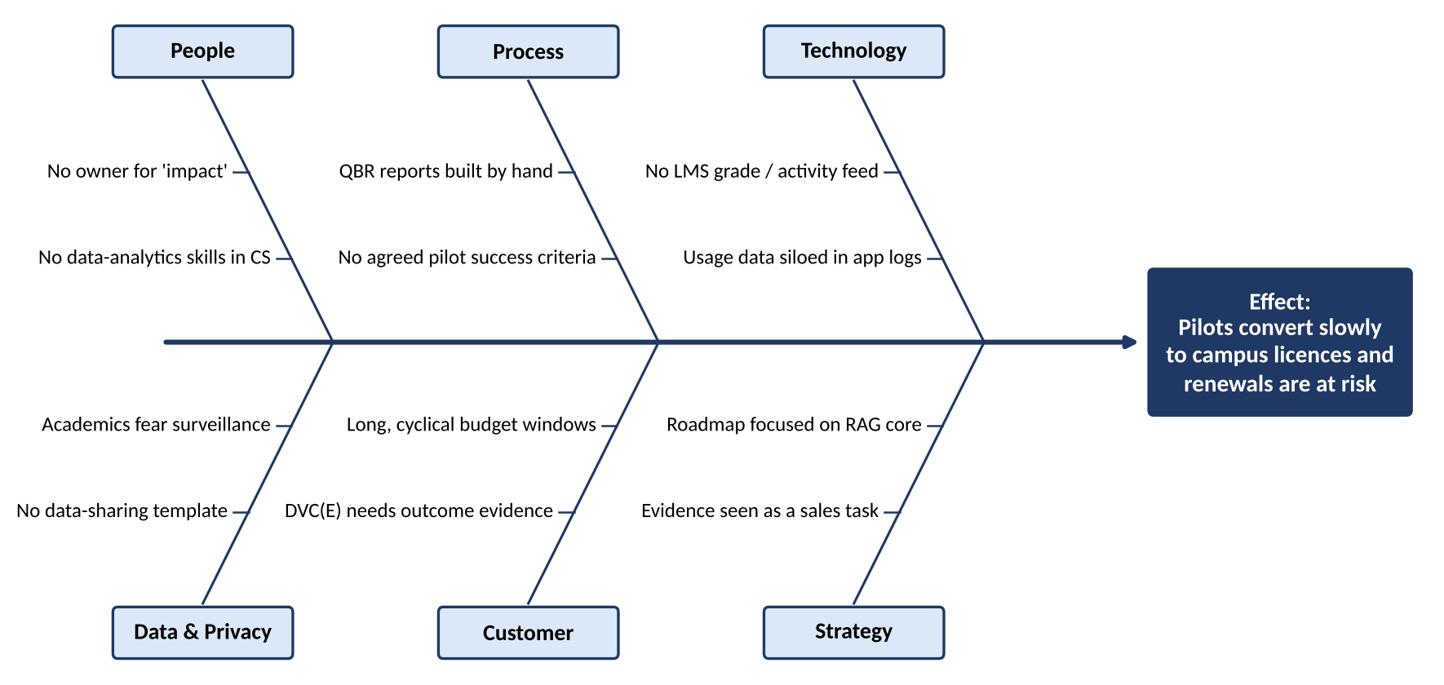
Figure 2. Fishbone diagram – causes of slow pilot-to-licence conversion
The fishbone supports the 5 Whys result and adds two contributing causes: academics' fear that analytics means surveillance, and the lack of a standard data-sharing agreement. Any solution must address both, because universities will not release the data needed to measure impact without them.
Draft IT-Enabled Proposal
Proposed IT initiative (High level idea)
We propose Lyra Impact Hub, a privacy-preserving learning-analytics module that measures and reports Lyra's effect on learning automatically. It has four components:
- Data connectors – LTI Advantage grade services and Caliper activity events bring LMS activity and assessment results into Lyra under a standard data-sharing agreement (1EdTech Consortium, 2019). Data is de-identified on arrival and stays in AWS Sydney.
- Impact analytics engine – compares matched groups of users and non-users with similar prior results, and groups students' questions into 'struggle topics' for each unit.
- Insight reports – an upgraded educator dashboard plus automatically generated pilot evaluations and QBR reports. A large language model writes plain-English summaries that cite the underlying figures, keeping Lyra's principle that every answer cites its source.
- Cost-to-serve view – inference spend per EFTSL for each licence, for internal margin management.
Privacy-by-design rules apply throughout: results are shown only for groups of at least ten students, individual staff or students are never ranked, and students can opt out. This mirrors good practice in learning analytics, where value depends on trust in how data is used (Siemens & Long, 2011).
The Hub creates value by turning evidence into a product capability, which removes the root cause above. University executives gain a defensible business case, academics see where students struggle, and customer success staff spend their time advising rather than compiling spreadsheets.
Business Value Proposition
In the business–IT alignment model, the Hub is an IT investment that builds a new IT capability (learning analytics) to strengthen a business capability (evidence-based customer success), creating organisational value for universities, academics, students and Lyra (The University of Sydney, 2026). Table 4 links each benefit to the BMC and to Lyra's FY2027 objectives.
Table 4. Benefits mapped to the Business Model Canvas and strategic objectives
Benefit | BMC block improved | FY2027 objective supported
Outcome evidence for every pilot shortens the path to a campus licence | Revenue Streams; Customer Relationships | Eight university-wide licences
QBRs show learning impact, not only usage | Customer Relationships | 90% renewal
Struggle-topic insights help academics adjust teaching | Value Proposition (academics) | 90% renewal; differentiation
Analytics sold as a premium module | Revenue Streams | Gross margin above 70%
QBR preparation falls from about two days to under two hours | Key Activities; Cost Structure | Gross margin above 70%
Inference cost visible per licence | Cost Structure | Gross margin above 70%
A growing, de-identified impact dataset becomes intellectual property | Key Resources | Long-term competitive advantage

The Hub also widens the market gap identified in About the Organisation. Consumer AI tools cannot provide institution-level evidence, and the generic analytics of LMS incumbents are not linked to curriculum-grounded study activity. Evidence of impact therefore becomes a competitive advantage that is hard to copy.
Preliminary Constraints
Table 5. Preliminary constraints and initial responses
Constraint | Description | Initial response
Budget | Seed funding is limited. One squad of about five people for five months competes with the core retrieval roadmap. | Build a minimum viable Hub first; sell analytics as a premium module. Estimate in AW6.
Timeline | Universities set budgets once a year, so evidence must exist before the mid-2027 renewal cycle. | Build over summer and pilot in Semester 1 2027.
Data access and privacy | Each university must approve data sharing under the Privacy Act 1988 (Cth) and, in NSW, the PPIP Act 1998. Publishing impact research may need ethics approval (National Health and Medical Research Council [NHMRC], 2023). | Standard data-sharing agreement and privacy impact assessment; de-identify at ingestion.
Resistance | Academics may see analytics as surveillance; customer success staff are used to manual reports; engineers may resist leaving the core roadmap. | Opt-in, aggregate-only design and a change management plan (AW8).
Skills | Lyra lacks data-engineering and evaluation-design expertise. | Hire one data analyst; train existing staff.
Integration | Canvas, Moodle and Blackboard implement LTI Advantage differently. | Start with Canvas, which most pilot universities use.
Evidence validity | Students who use Lyra may already be more motivated (self-selection bias). | Report results as associations with clear limits; review the method with the Academic Advisory Board.

References
1EdTech Consortium. (2019). Learning Tools Interoperability core specification (Version 1.3). https://www.imsglobal.org/spec/lti/v1p3
Corporations Act 2001 (Cth). https://www.legislation.gov.au/C2004A00818/latest
International Organization for Standardization. (2024). Information technology – Governance of IT for the organization (ISO/IEC Standard No. 38500:2024).
Ishikawa, K. (1990). Introduction to quality control. 3A Corporation.
Mintzberg, H. (1979). The structuring of organizations: A synthesis of the research. Prentice-Hall.
National Health and Medical Research Council. (2023). National statement on ethical conduct in human research 2023. https://www.nhmrc.gov.au/about-us/publications/national-statement-ethical-conduct-human-research-2023
Ohno, T. (1988). Toyota production system: Beyond large-scale production. Productivity Press.
Osterwalder, A., & Pigneur, Y. (2010). Business model generation: A handbook for visionaries, game changers, and challengers. John Wiley & Sons.
Privacy Act 1988 (Cth). https://www.legislation.gov.au/C2004A03712/latest
Privacy and Personal Information Protection Act 1998 (NSW). https://legislation.nsw.gov.au/view/html/inforce/current/act-1998-133
Siemens, G., & Long, P. (2011). Penetrating the fog: Analytics in learning and education. EDUCAUSE Review, 46(5), 30–40.
The University of Sydney. (2026). Week 02: Creating organisational value from IT investments [Lecture slides]. INFO5990 Professional Practice in IT, Canvas.
Weill, P., & Ross, J. W. (2004). IT governance: How top performers manage IT decision rights for superior results. Harvard Business School Press.

